Last Name: | First Name:
Middle Name: | Maiden/Former Name:
Last 4 of Social Security #: _____________  PCC Student ID # ___________________ | Date of Birth:
Please do not use nicknames or aliases. Enter only your legal name.
Email Address:
Mailing Address Line 1:
Mailing Address Line 2:
City: | State: | Zip Code:
Cell Phone: ( ) | Home Phone: ( )

High School Diploma | Month:/Year:
GED/ HS Equivalency | Month/Year:
Application to the College must be completed before the Application for Practical Nursing Diploma Program will be considered.
Have you ever been enrolled in any nursing program at another institution? Yes No
If so, which school or program: ______________________________________________
Have you had all official transcripts sent to PCC or plan to do so prior to November 1? Yes No

I certify that the information provided on this application is complete and correct to the best of
my knowledge.

Signature: | Date:

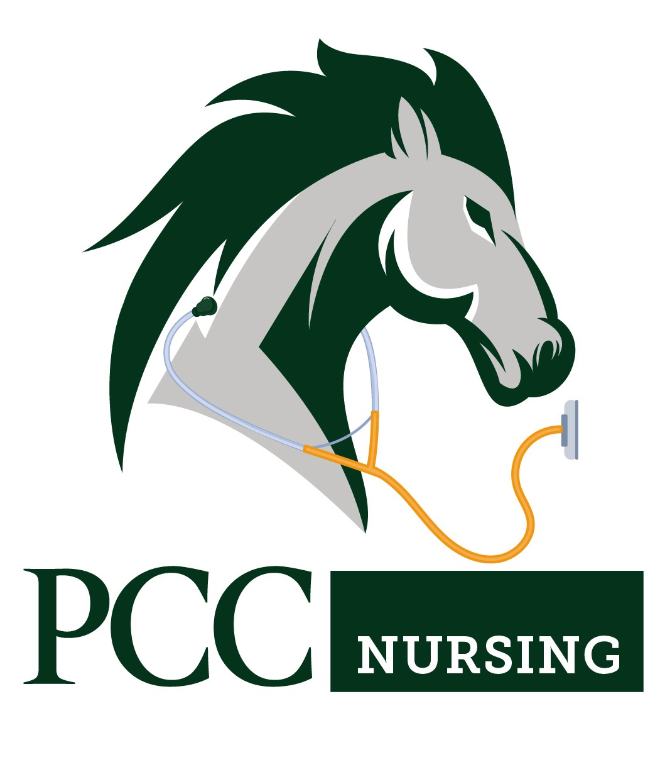
Please mail or hand deliver this application to the following address:

Piedmont Community College
Office of Admissions
PO Box 1197
Roxboro, NC 27573

