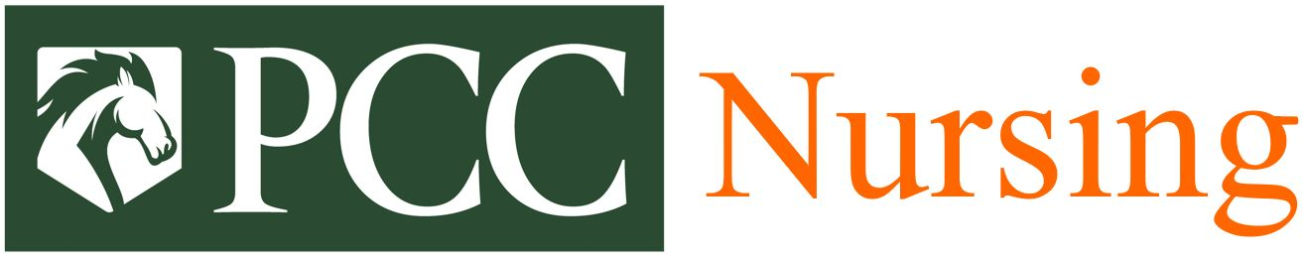
NURSING ADMISSIONS TEST (TEAS) Application
For the Cohort Starting August 2026 on the Person County Campus

The TEAS will be offered on the Person County campus on following dates & times:
Friday, January 23rd : 9:00 am
Wednesday, February 4th : 9:00 am
Friday, February 13th : 1:00 pm
Wednesday, February 18th : 1:00 pm
Saturday, February 21st : 1:00 pm
Monday, February 23rd : 9:00 am
Monday, February 23rd : 1:00 pm
Friday, February 27th : 9:00 am

Application to Test

Student Name: __________________________ Student ID#: ___________________

Email Address: __________________________ Telephone Number: _____________
Requested Test Date: _____________________ Requested Test Time: ____________

Please complete this section and confirm eligibility prior to submitting application to test.
- My official transcripts support that I have shown proficiency in math, reading, and writing by placing into ENG 111 and MAT 143 or 152 without the co-requisite course.
- I understand that if I have earned a “D” or “F” in a required course for the ADN program, the course must be repeated prior to entering the PCC Nursing program and earn a grade of “C” or better.
- I am prepared to take the PCC Nursing Admissions Test (TEAS), understand that I can only take the test three times in a 6-month period, and must have at least a two-week remediation period between attempts.
- I understand that the highest overall TEAS score within the 6-month period before the PCC ADN Admissions application deadline will be used for consideration.
- I understand that the $70 testing fee is non-refundable and will need to be paid with a debit/credit card at the time of testing.
- I understand that if I qualify for testing accommodations based on a disability, I must request accommodations with the PCC Accessibility Services in the PCC Student Development Office prior to scheduling the TEAS and I will notify the Director of the PCC Nursing program.
- I understand that I will not be allowed to take the TEAS without TWO forms of identification (one of which MUST be a government-issued photo ID).
Student Signature: __________________________________ Date: ___________________

